A000-AM,S-Peru-Moche-Figure-Seated-Male with Helmet-Black-Stirrup Ceramic-100 CE

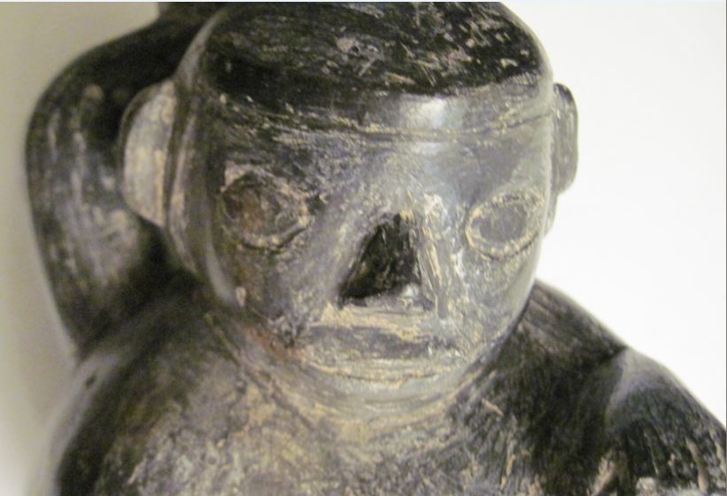

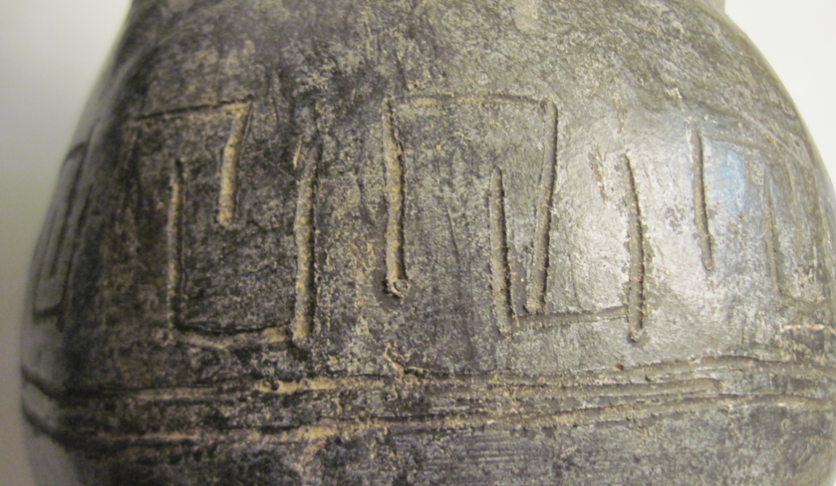

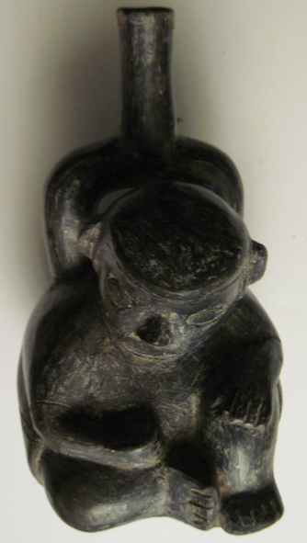

**Case No.:**

**Accession No.**

**Formal Label:** Moche-Figure-Seated-Male with Helmet-Black-Stirrup Ceramic-100 CE

**Display Description:**

This Moche Figure of a seated-male with a cap-like helmet in a black stirrup ceramic jar suggests he is an attendant at one of the ceremonial gatherings. His seated position suggests obsequiousness and his almond eyes are typically in the Moche style.

**LC Classification: F3430.1.**

**Date or Time Horizon:** 100 CE

**Geographical Area:** North coastal Peru

**Map, GPS coordinates: -6.80139 -79.60202; 6º48'5" S 79º36'7.28" W.**

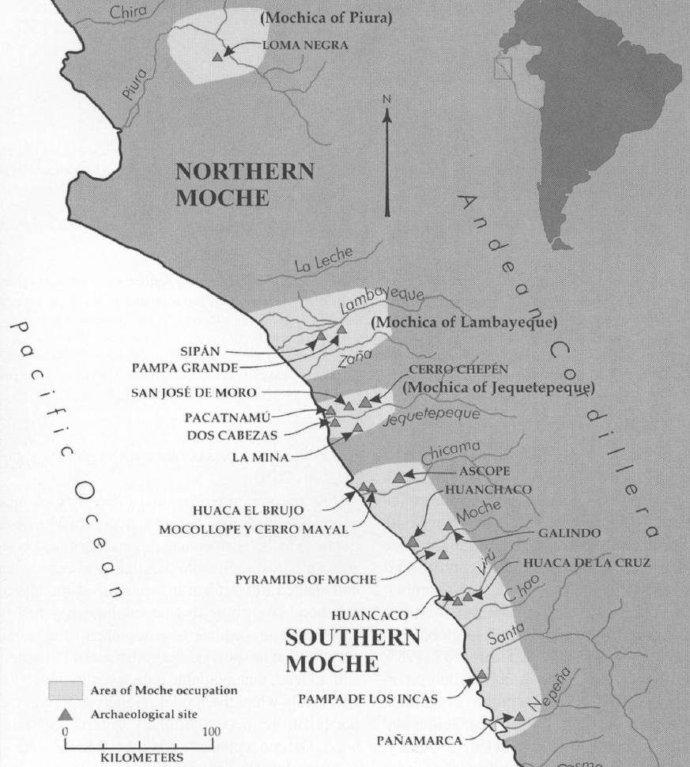

Fig. 6. Map of Moche regions as currently conceived and significant Moche sites. Map courtesy Moro Archaeological program.

**Cultural Affiliation:** Moche, Mochica

**Media:** clay; black firing

**Dimensions:** H mm; in

**Weight: gm; oz**

**Condition: original**

**Provenance:** Garcia Fernandez collected this ceramic while living in Peru 1950-1980.

**Discussion:**

**References:**

Alva, Waltsr and Chrisopher R. Donnan. 1993. *Royal Tombs of Sipan*, Fowler Museum of Cultural History, Los Angeles: UCLA.

[Anon.](https://en.wikipedia.org/wiki/Moche_culture#cite_ref-4)  [The Salinar Culture](http://www.tampere.fi/ekstrat/taidemuseo/arkisto/peru/800/salinar_en.htm) Tampere Museum

Bawden, G. 2004. "The Art of Moche Politics". In Silverman, H. **Andean Archaeology**. Oxford: Blackwell Publishers.

Beck, Roger B.; Black, Linda; Krieger, Larry S.; Naylor, Phillip C.; Shabaka, Dahia Ibo (1999). *World History: Patterns of Interaction.* Evanston, IL: McDougal Littell. [ISBN](https://en.wikipedia.org/wiki/International_Standard_Book_Number) [0-395-87274-X](https://en.wikipedia.org/wiki/Special:BookSources/0-395-87274-X).

Benson, Elizabeth P. 1972 *The Mochica, a culture of Per*u. New Yorlr, Washington, D.C.: Praeger Publishers.

Benson, Elizabeth P. 1974. *A Man and a Feline in Mochica Art*. Washington, D.C.: Dumbarton Oaks, Trustees for Harvard University.

Butters, Castillo and Luis Jaime. ["Moche Politics in the Jequetepeque Valley"](http://sanjosedemoro.pucp.edu.pe/descargas/articulos/MocheJequetepeque.pdf) (PDF). Retrieved 2012-11-23

Butters, Castillo.2007. "The Moche of Northern Perú". In Silverman, H.; Isbell, W. [*Handbook of South American Archaeology*](http://sanjosedemoro.pucp.edu.pe/descargas/articulos/TheMochePeru.pdf) (PDF). Blackwell Press.

Cardenas, Maritza (ed.). ["Huacas del Sol y de la Luna – Capital de la Cultura-Mochica"](http://sobre-peru.com/2009/09/11/cultura-mochica-pre-inca-en-el-norte-peruano/) (in Spanish). Retrieved 2012-03-29.

Chapdelaine, Claude; Kennedy, Greg; Uceda Castillo, Santiago (1995). ["Neutron activation analysis and local production of ritual ceramics at the Moche site, Peru"](http://www.ifeanet.org/publicaciones/boletines/24(2)/183.pdf) (PDF). *Bulletin de l'Institut Francais d'Etudes Andines* 24 (2): 183–212.

[Keys, David](https://en.wikipedia.org/wiki/David_Keys_(author)). 2000. "The Mud of Hades". *Catastrophe: an Investigation into the Origins of the Modern World* (1st [American] ed.). New York: Ballantine Books. [ISBN](https://en.wikipedia.org/wiki/International_Standard_Book_Number) [0345444361](https://en.wikipedia.org/wiki/Special:BookSources/0345444361).

Davidson, Nick. 2 March 2005. ["Lost society tore itself apart"](http://news.bbc.co.uk/2/hi/science/nature/4311153.stm). BBC Horizon. Retrieved 2005-05-04.

Lovett, Richard A. August 18, 2006. ["Photo in the News: Looted Peru Headdress Recovered in London"](http://news.nationalgeographic.com/news/2006/08/060818-peru-headdress.html). *National Geographic News*. Retrieved 2010-12-18.

McClellan III, James E.; Harold Dorn. 2006. [*Science and Technology in World History: An Introductio*n](https://books.google.com/books?id=aJgp94zNwNQC). JHU Press; 14 April 2006.  p. 40.

Norris, Scott (May 16, 2006). ["Mummy of Tattooed Woman Discovered in Peru Pyramid"](http://news.nationalgeographic.com/news/2006/05/mummy-peru.html). *National Geographic News.*

Popson, C. 2012. ["Moche Culture"](http://www.about-peru-history.com/moche-culture.html). *About Peru History*. Retrieved 2012-05-22.

[Scher](https://smarthistory.org/author/dr-sarahh-scher/), Dr. Sarahh and [Steven Zucker](https://smarthistory.org/author/szucker/). 2015. ["Pair of Earflares, Winged Messengers (Moche Culture, Peru)"](http://smarthistory.org/pair-of-earflares-winged-messengers/). *[Smarthistory](https://en.wikipedia.org/wiki/Smarthistory" \o "Smarthistory).*

Sharon, Douglas. 2000. *Shamanism and the sacred cactus: ethnoarchaeolgical evidence for the San Pedro use in northern Peru.* San Diego: San Diego Museum of Man.

Sutherland, Scott. August 29, 2013. ["Unearthed Peruvian tomb confirms that women ruled over brutal ancient culture"](https://news.yahoo.com/blogs/geekquinox/unearthed-peruvian-tomb-confirms-women-ruled-over-brutal-160013738.html). *Yahoo! News*. Retrieved 2013-08-29.

Vecchio, Rick. September 15, 2006. ["Looted gold headdress returned to Peru"](http://archive.peruthisweek.com/news-2448-looted-gold-headdress-returned-to-peru/). *Peru This Week.* AP.

Williams. Ann R. 2013. “[Tomb of a Powerful Moche Priestess-Queen Found in Peru.](http://news.nationalgeographic.com/news/http-/news/news/2013/08/130808-moche-priestess-queen-tomb-discovery-peru-archaeology-science/)”  nationalgeographic.com

Weismantel, M. 2004. ["Moche sex pots: Reproduction and temporality in ancient South America"](http://www.latinamericanstudies.org/moche/moche-sex-pots.pdf) (PDF). *American Anthropologist*. 106 (3): 495–496.

[Zucker, Steven, and Dr. Sarahh Scher, 2016. Moche Portrait Head Bottle"](http://smarthistory.org/moche-portrait-bottle/). *[Smarthistory](https://en.wikipedia.org/wiki/Smarthistory" \o "Smarthistory).*